**DAILY ONLINE ACTIVITIES SUMMARY**

|  |  |  |  |  |  |  |  |  |
| --- | --- | --- | --- | --- | --- | --- | --- | --- |
| **Date:** | **23-06-2020** | | | | | **Name:** | **Sinchana** | |
| **Sem & Sec** | **6 B** | | | | | **USN:** | **4AL17CS117** | |
| **Online Test Summary** | | | | | | | | |
| **Subject** | | **JAVA and J2EE programming**  **Data structures** | | | | | | |
| **Max. Marks** | |  | | **Score** | | |  | |
| **Certification Course Summary** | | | | | | | | |
| **Course** | **JAVA and J2EE programming** Data structures | | | | | | | |
| **Certificate Provider** | | | **Mr.Sharan**  **Mrs.Merlyn** | | **Duration** | | | **4 hrs** |
| **Coding Challenges** | | | | | | | | |
| **Problem Statement: 1Java program** | | | | | | | | |
| **Status: Success** | | | | | | | | |
| **Uploaded the report in Github** | | | | | **Yes** | | | |
| **If yes Repository name** | | | | | **coding** | | | |
| **Uploaded the report in slack** | | | | | **Yes** | | | |

Online Test Details: (Attach the snapshot and briefly write the report for the same)

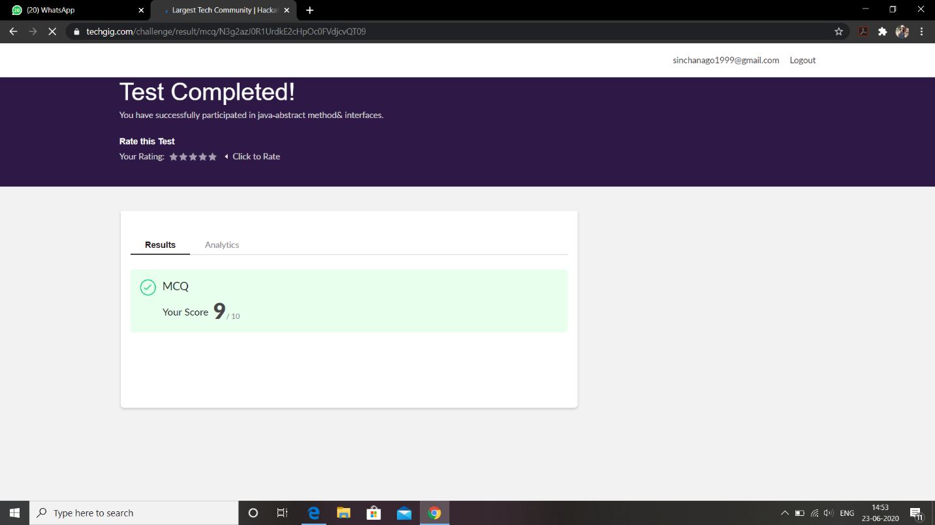

This is the response JAVA programming test and this is the snapshot of this.

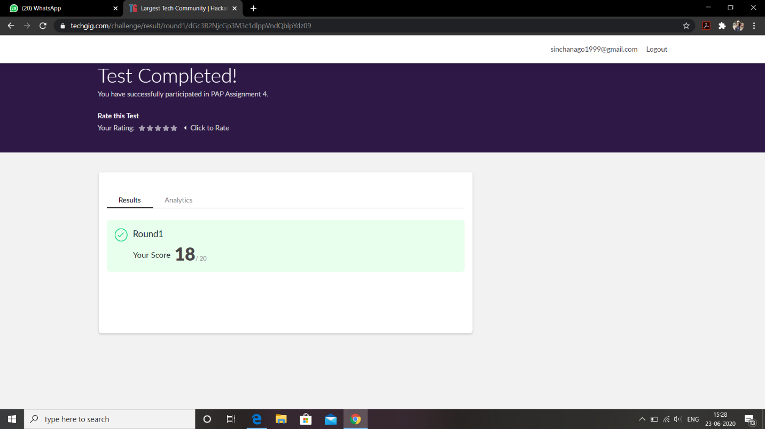

This is the response python programming test and this is the snapshot of this.

Certification Course Details: (Attach the snapshot and briefly write the report for the same)

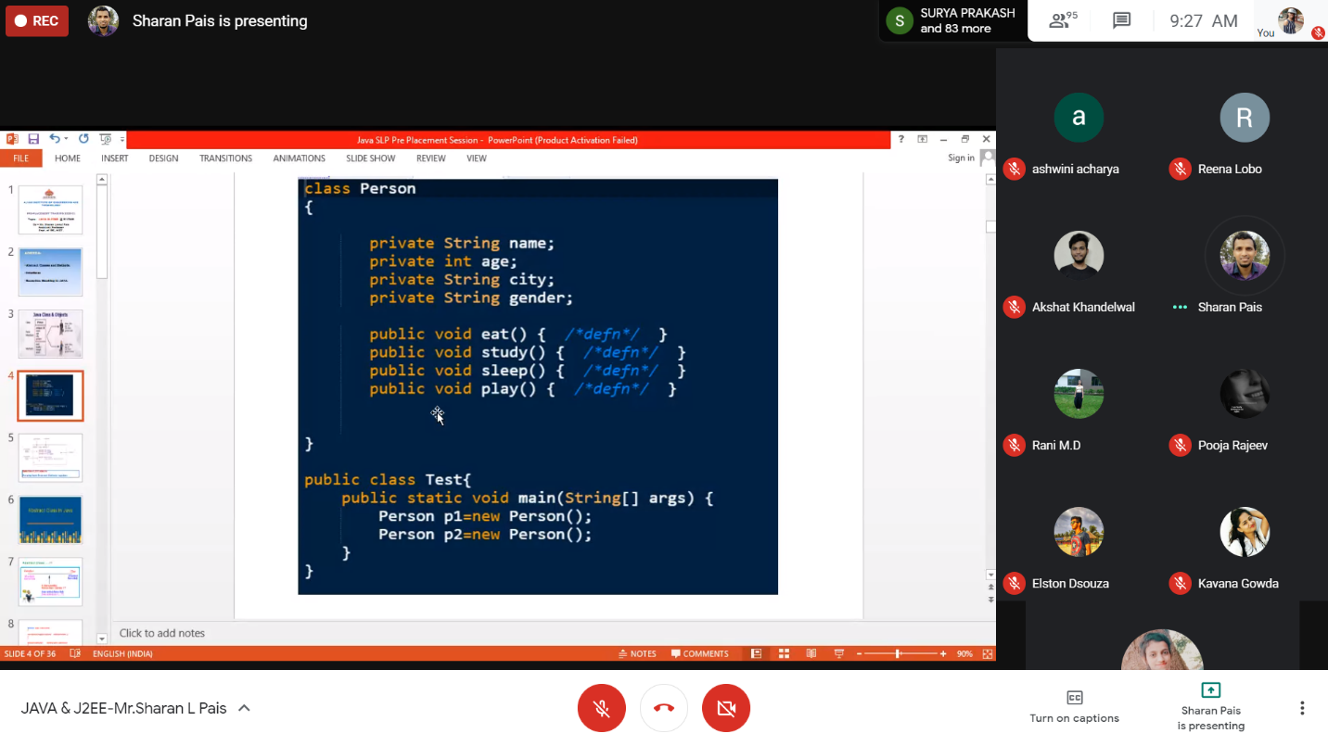

Today I have learnt about basics of JAVA and J2EE programming in which there where several examples where explained.

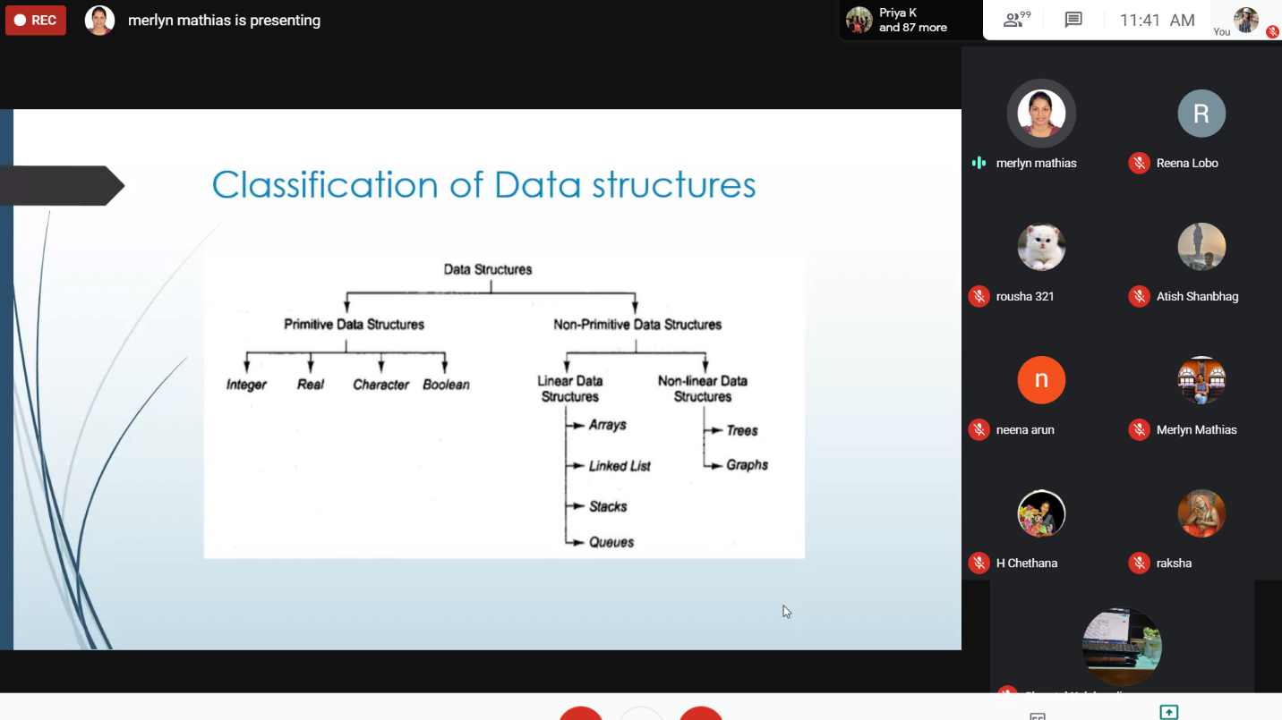

Today I have learnt about Data structures and several examples where explained.

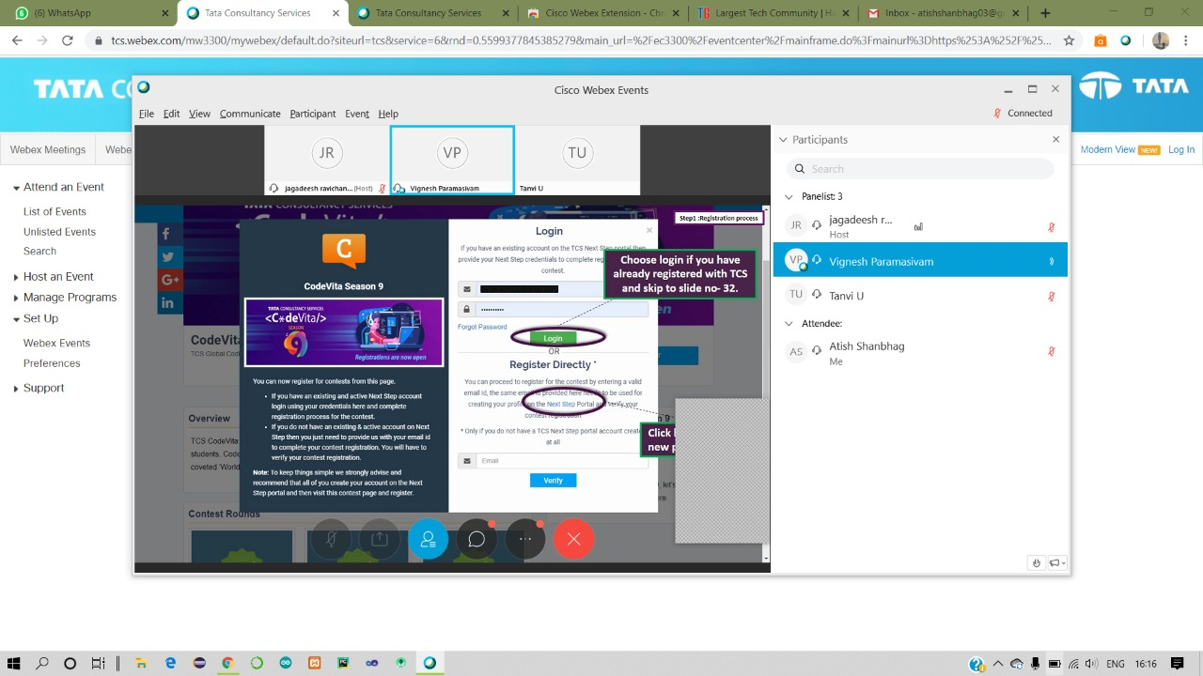

There was a webinar conducted by codevita.

Coding Challenges Details: (Attach the snapshot and briefly write the report for the same)

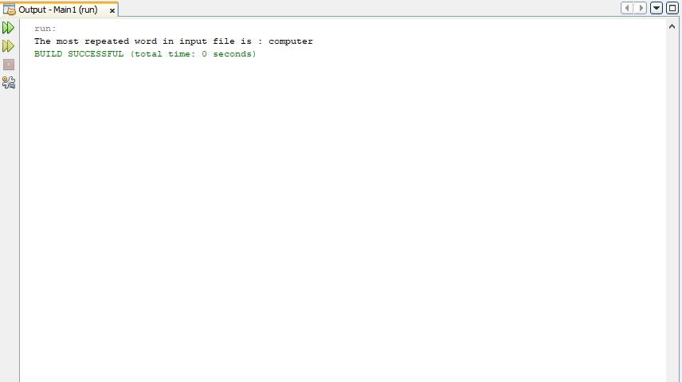

Link in Github :

1. Coding and Word document

<https://github.com/sinchana514/coding/tree/master/24th%20june>